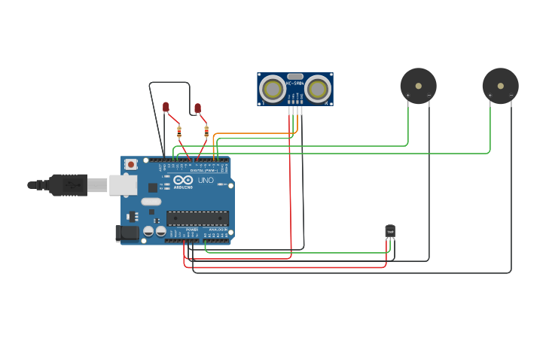**TINKERCAD LAYOUT**